BABU BANARASI DAS UNIVERSITY
2026-2027


SCHOOL OF COMPUTER APPLICATIONS

No SQL Project On
Student Management System Using MongoDB

Submitted to: Submitted by:
Mr. Harendra Singh Heena Hemwani
Department: BCA (DS & AI) Roll no: (52)
Date: 25th September University roll no: 1250258218

- CREATE DATABASE
use Students
This creates/switches to a database called Students.

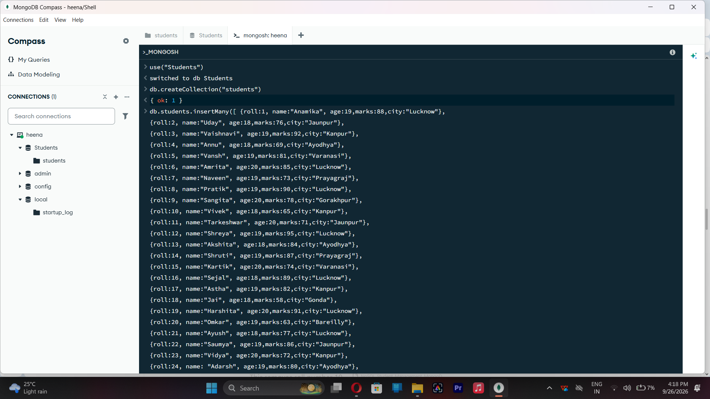

2. CREATE COLLECTION
db.createCollection("students")

Creates a collection named students.

3.INSERT 50 STUDENTS
db.students.insertMany([
{roll:1, name:"Anamika", age:19,marks:88,city:"Lucknow"},
{roll:2, name:"Uday", age:18,marks:76,city:"Jaunpur"},
{roll:3, name:"Vaishnavi", age:19,marks:92,city:"Kanpur"},
{roll:4, name:"Annu", age:18,marks:69,city:"Ayodhya"},
{roll:5, name:"Vansh", age:19,marks:81,city:"Varanasi"},
{roll:6, name:"Amrita", age:20,marks:85,city:"Lucknow"},
{roll:7, name:"Naveen", age:19,marks:73,city:"Prayagraj"},
{roll:8, name:"Pratik", age:19,marks:90,city:"Lucknow"},
{roll:9, name:"Sangita", age:20,marks:78,city:"Gorakhpur"},
{roll:10, name:"Vivek", age:18,marks:65,city:"Kanpur"},
{roll:11, name:"Tarkeshwar", age:20,marks:71,city:"Jaunpur"},
{roll:12, name:"Shreya", age:19,marks:95,city:"Lucknow"},
{roll:13, name:"Akshita", age:18,marks:84,city:"Ayodhya"},
{roll:14, name:"Shruti", age:19,marks:87,city:"Prayagraj"},
{roll:15, name:"Kartik", age:20,marks:74,city:"Varanasi"},
{roll:16, name:"Sejal", age:18,marks:89,city:"Lucknow"},
{roll:17, name:"Astha", age:19,marks:82,city:"Kanpur"},
{roll:18, name:"Jai", age:18,marks:58,city:"Gonda"},
{roll:19, name:"Harshita", age:20,marks:91,city:"Lucknow"},
{roll:20, name:"Omkar", age:19,marks:63,city:"Bareilly"},
{roll:21, name:"Ayush", age:18,marks:77,city:"Lucknow"},
{roll:22, name:"Saumya", age:19,marks:86,city:"Jaunpur"},
{roll:23, name:"Vidya", age:20,marks:72,city:"Kanpur"},
{roll:24, name: "Adarsh", age:19,marks:80,city:"Ayodhya"},
{roll:25, name: "Anmol", age:18,marks:67,city:"Prayagraj"},
{roll:26, name: "Anushka", age:20,marks:94,city:"Lucknow"},
{roll:27, name: "Ananya", age:19,marks:88,city:"Varanasi"},
{roll:28, name: "Bhaskar", age:18,marks:61,city:"Gorakhpur"},
{roll:29, name: "Rohan", age:19,marks:75,city:"Kanpur"},
{roll:30, name: "Nishant", age:20,marks:79,city:"Lucknow"},
{roll:31, name: "Vineet", age:18,marks:68,city:"Jaunpur"},
{roll:32, name: "Anika", age:19,marks:90,city:"Lucknow"},
{roll:33, name: "Jai", age:20,marks:55,city:"Ayodhya"},
{roll:34, name: "Lakshya", age:18,marks:83,city:"Kanpur"},
{roll:35, name: "Krishna", age:19,marks:96,city:"Prayagraj"},
{roll:36, name: "Rumana", age:20,marks:70,city:"Lucknow"},
{roll:37, name: "Priyanshu", age:18,marks:81,city:"Varanasi"},
{roll:38, name: "Aditya", age:19,marks:66,city:"Gorakhpur"},
{roll:39, name: "Dhruv", age:20,marks:93,city:"Lucknow"},
{roll:40, name: "Nivedita", age:19,marks:85,city:"Kanpur"},
{roll:41, name: "Meenu", age:18,marks:74,city:"Jaunpur"},
{roll:42, name: "Akanksha", age:20,marks:89,city:"Lucknow"},
{roll:43, name: "Sarika",age:19,marks:62,city:"Ayodhya"},
{roll:44, name: "Anchal",age:18,marks:78,city:"Prayagraj"},
{roll:45, name: "Umra", age:20,marks:84,city:"Lucknow"},
{roll:46, name: "Nashra", age:19,marks:73,city:"Kanpur"},
{roll:47, name: "Aman", age:18,marks:59,city:"Gonda"},
{roll:48, name: "Priya", age:20,marks:87,city:"Lucknow"},
{roll:49, name: "Rahul", age:19,marks:64,city:"Bareilly"},
{roll:50, name: "Neha", age:18,marks:91,city:"Varanasi"}
])

Inserts multiple student documents into the collection.

db.students.insertMany([ {roll:1, name:"Anamika", age:19,marks:88,city:"Lucknow"},
{roll:2, name:"Uday", age:18,marks:76,city:"Jaunpur"},
{roll:3, name:"Vaishnavi", age:19,marks:92,city:"Kanpur"},
{roll:4, name:"Annu", age:18,marks:69,city:"Ayodhya"},
{roll:5, name:"Vansh", age:19,marks:81,city:"Varanasi"},
{roll:6, name:"Amrita", age:20,marks:85,city:"Lucknow"},

{roll:7, name:"Naveen", age:19,marks:73,city:"Prayagraj"},
{roll:8, name:"Pratik", age:19,marks:90,city:"Lucknow"},
{roll:9, name:"Sangita", age:20,marks:78,city:"Gorakhpur"},
{roll:10, name:"Vivek", age:18,marks:65,city:"Kanpur"},
{roll:11, name:"Tarkeshwar", age:20,marks:71,city:"Jaunpur"},
{roll:12, name:"Shreya", age:19,marks:95,city:"Lucknow"},
{roll:13, name:"Akshita", age:18,marks:84,city:"Ayodhya"},
{roll:14, name:"Shruti", age:19,marks:87,city:"Prayagraj"},
{roll:15, name:"Kartik", age:20,marks:74,city:"Varanasi"},
{roll:16, name:"Sejal", age:18,marks:89,city:"Lucknow"},
{roll:17, name:"Astha", age:19,marks:82,city:"Kanpur"},
{roll:18, name:"Jai", age:18,marks:58,city:"Gonda"},
{roll:19, name:"Harshita", age:20,marks:91,city:"Lucknow"},
{roll:20, name:"Omkar", age:19,marks:63,city:"Bareilly"},
{roll:21, name:"Ayush", age:18,marks:77,city:"Lucknow"},
{roll:22, name:"Saumya", age:19,marks:86,city:"Jaunpur"},
{roll:23, name:"Vidya", age:20,marks:72,city:"Kanpur"},
{roll:24, name: "Adarsh", age:19,marks:80,city:"Ayodhya"},
{roll:25, name: "Anmol", age:18,marks:67,city:"Prayagraj"},
{roll:26, name: "Anushka", age:20,marks:94,city:"Lucknow"},
{roll:27, name: "Ananya", age:19,marks:88,city:"Varanasi"},
{roll:28, name: "Bhaskar", age:18,marks:61,city:"Gorakhpur"},
{roll:29, name: "Rohan", age:19,marks:75,city:"Kanpur"},
{roll:30, name: "Nishant", age:20,marks:79,city:"Lucknow"},
{roll:31, name: "Vineet", age:18,marks:68,city:"Jaunpur"},
{roll:32, name: "Anika", age:19,marks:90,city:"Lucknow"},
{roll:33, name: "Jai", age:20,marks:55,city:"Ayodhya"},
{roll:34, name: "Lakshya", age:18,marks:83,city:"Kanpur"},
{roll:35, name: "Krishna", age:19,marks:96,city:"Prayagraj"},
{roll:36, name: "Rumana", age:20,marks:70,city:"Lucknow"},
{roll:37, name: "Priyanshu", age:18,marks:81,city:"Varanasi"},
{roll:38, name: "Aditya", age:19,marks:66,city:"Gorakhpur"},
{roll:39, name: "Dhruv", age:20,marks:93,city:"Lucknow"},
{roll:40, name: "Nivedita", age:19,marks:85,city:"Kanpur"},
{roll:41, name: "Meenu", age:18,marks:74,city:"Jaunpur"},
{roll:42, name: "Akanksha", age:20,marks:89,city:"Lucknow"},
{roll:43, name: "Sarika",age:19,marks:62,city:"Ayodhya"},
{roll:44, name: "Anchal",age:18,marks:78,city:"Prayagraj"},
{roll:45, name: "Umra", age:20,marks:84,city:"Lucknow"},
{roll:46, name: "Nashra", age:19,marks:73,city:"Kanpur"},
{roll:47, name: "Aman", age:18,marks:59,city:"Gonda"},
{roll:48, name: "Priya", age:20,marks:87,city:"Lucknow"},
{roll:49, name: "Rahul", age:19,marks:64,city:"Bareilly"},
{roll:50, name: "Neha", age:18,marks:91,city:"Varanasi"}
])

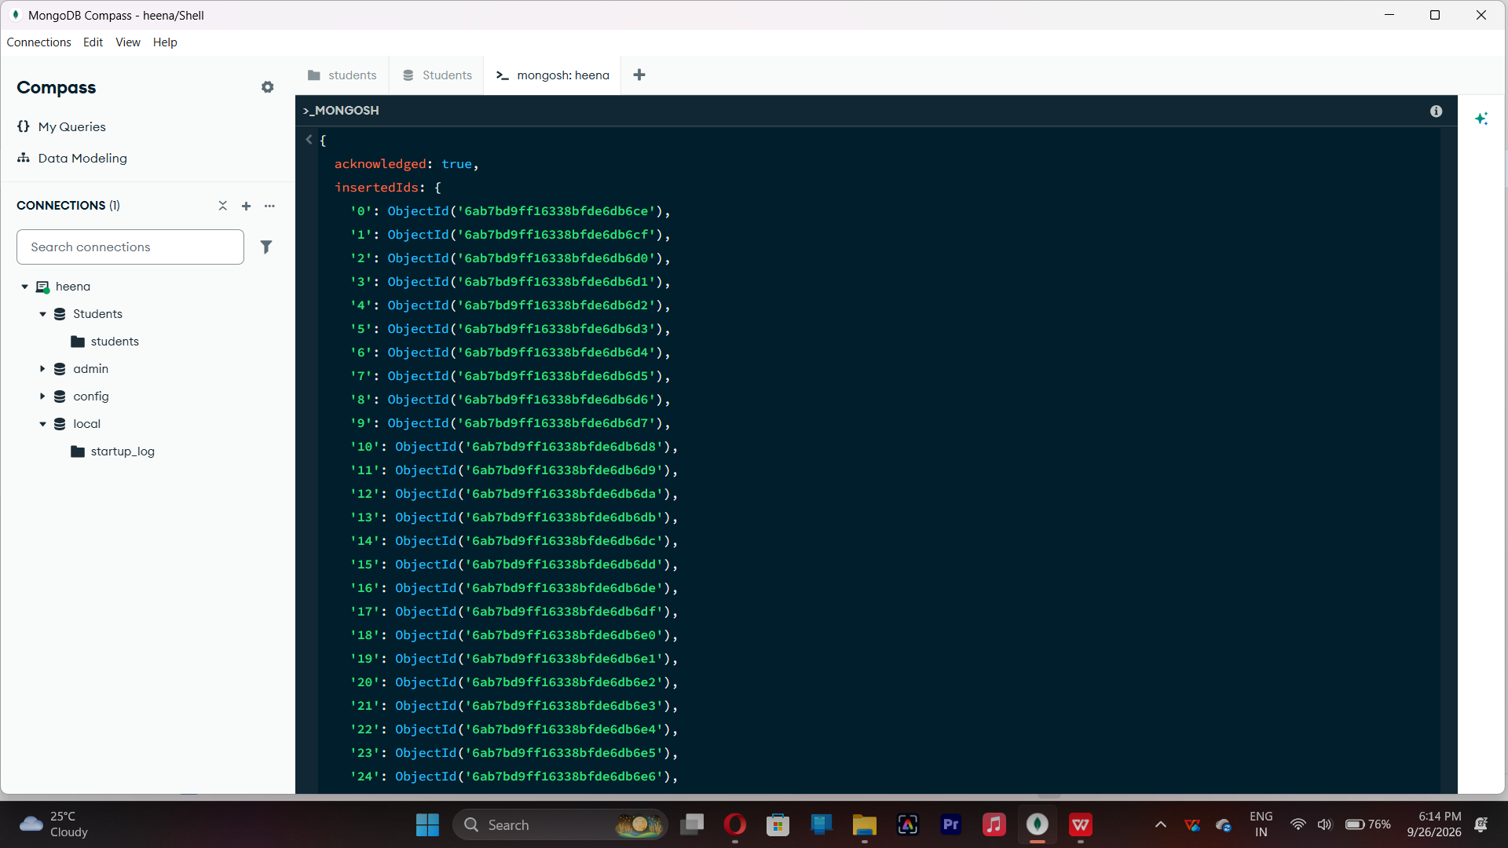

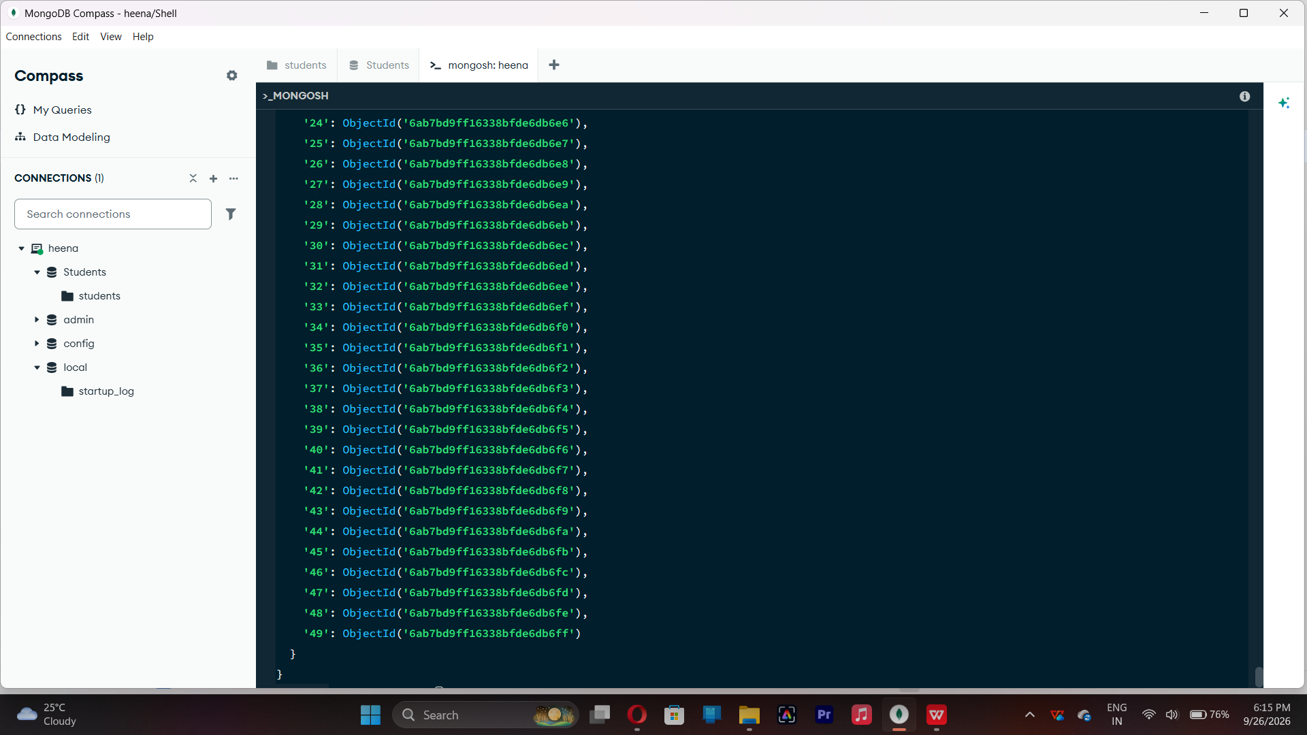

- DISPLAY ALL STUDENTS
db.students.find()

This displays the documents from students collection.

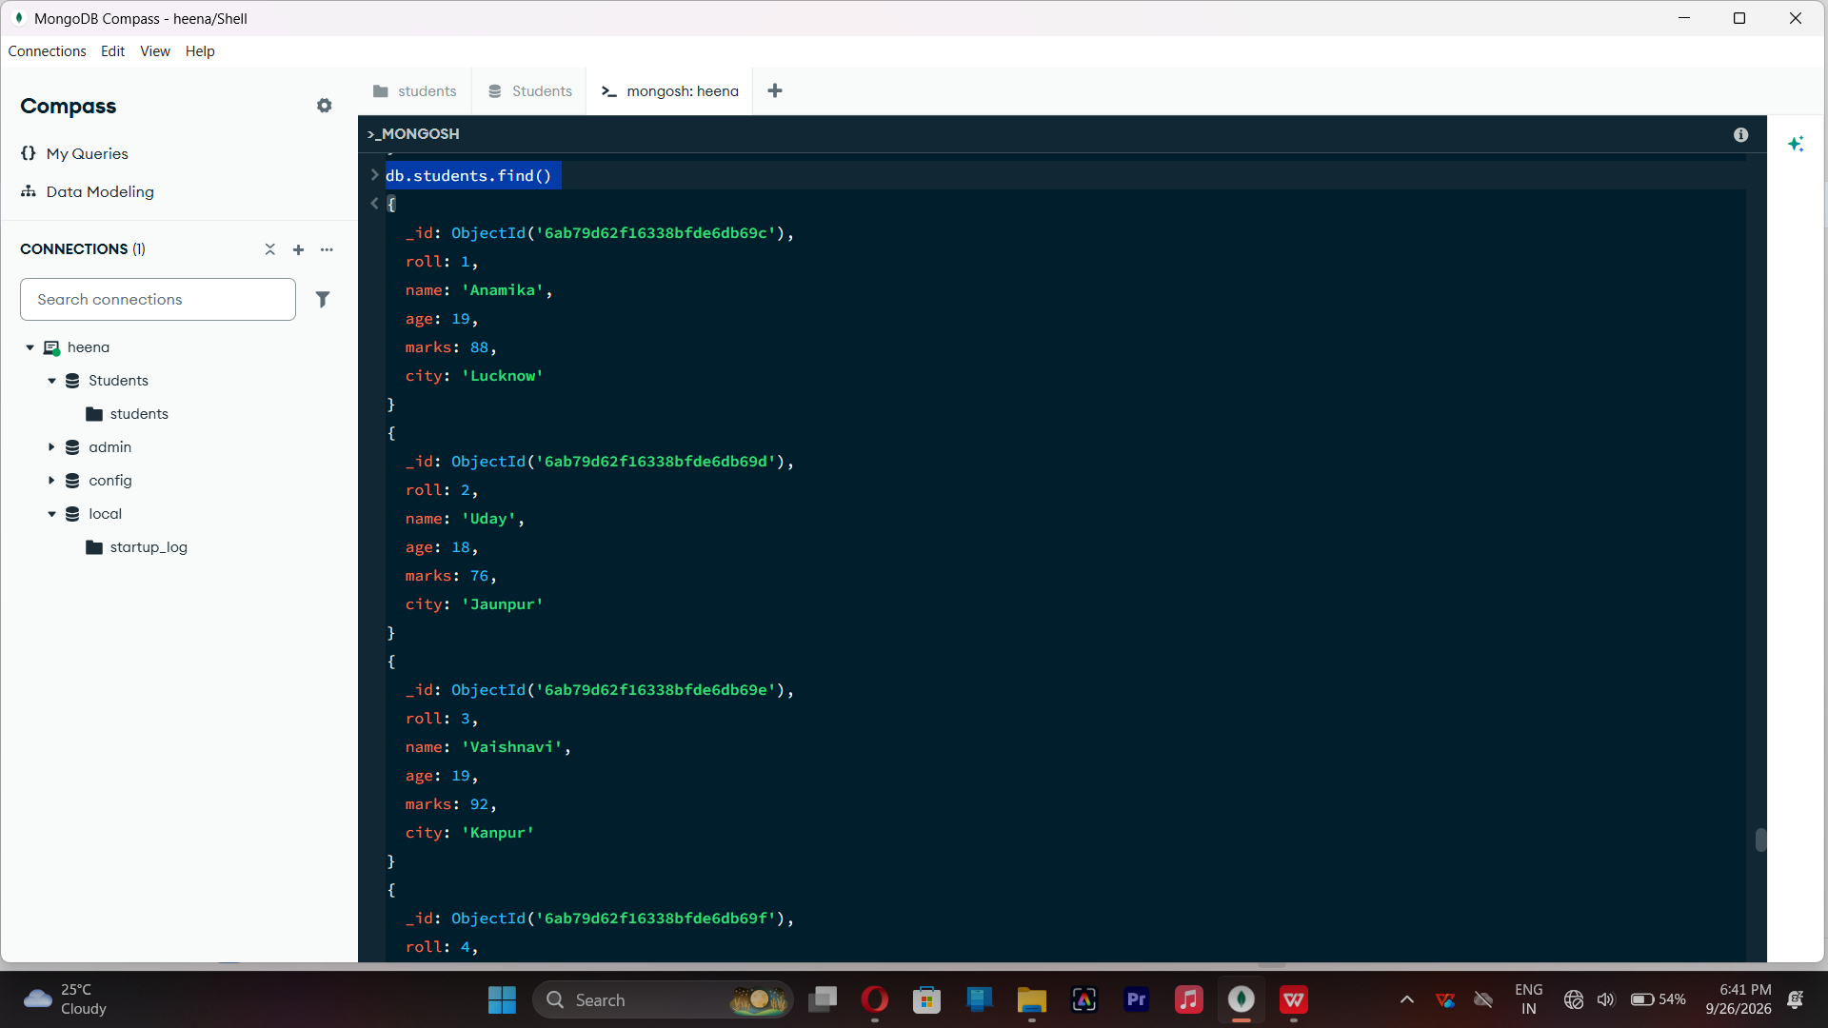
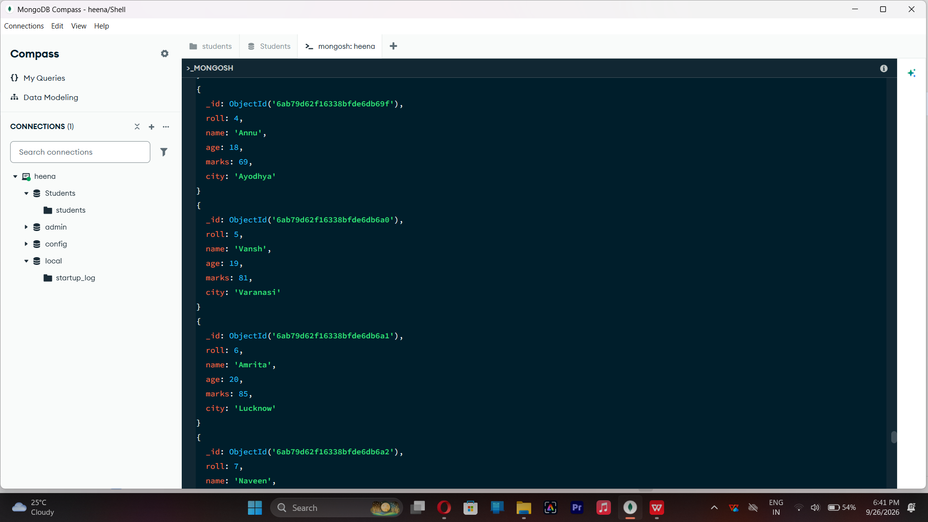

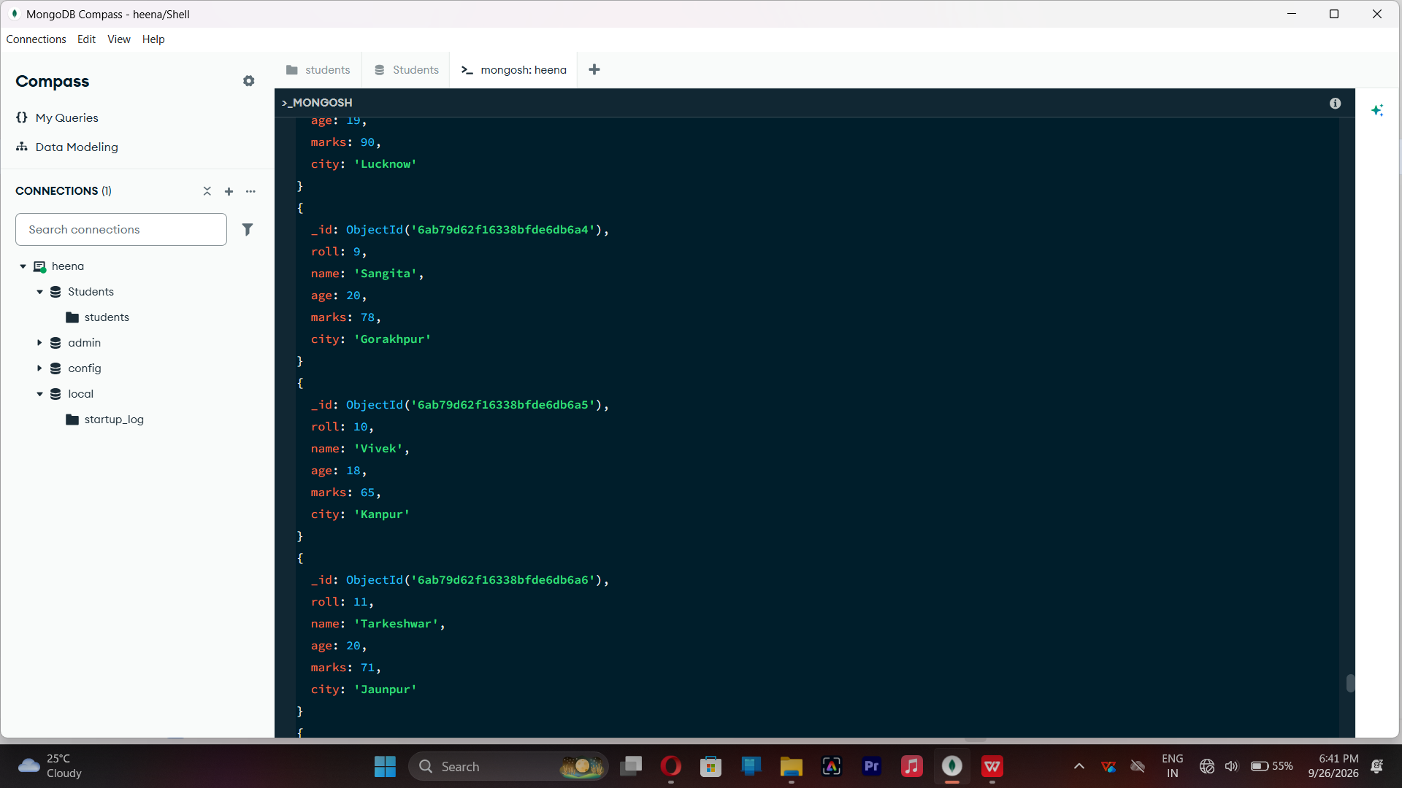

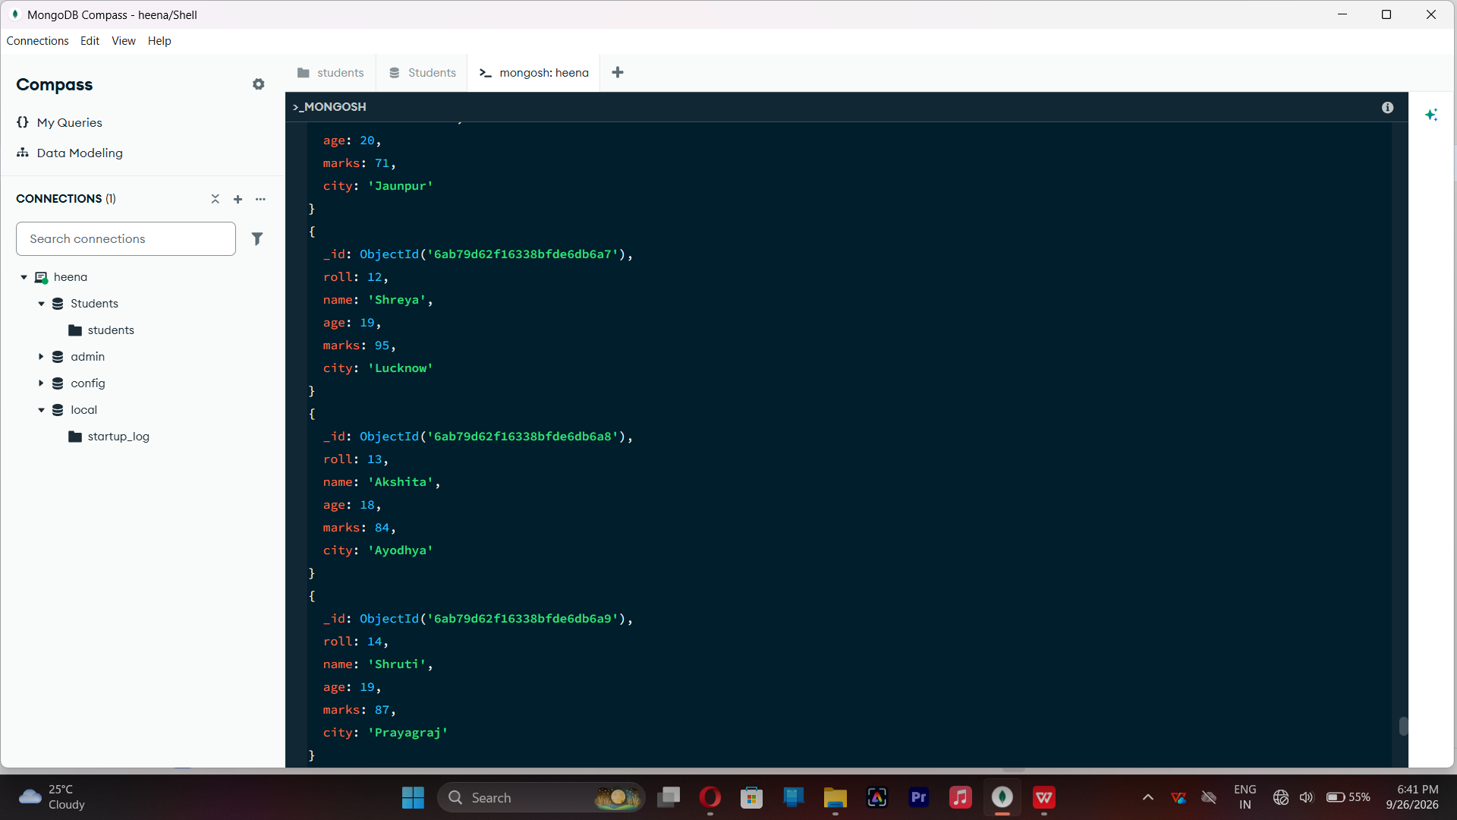

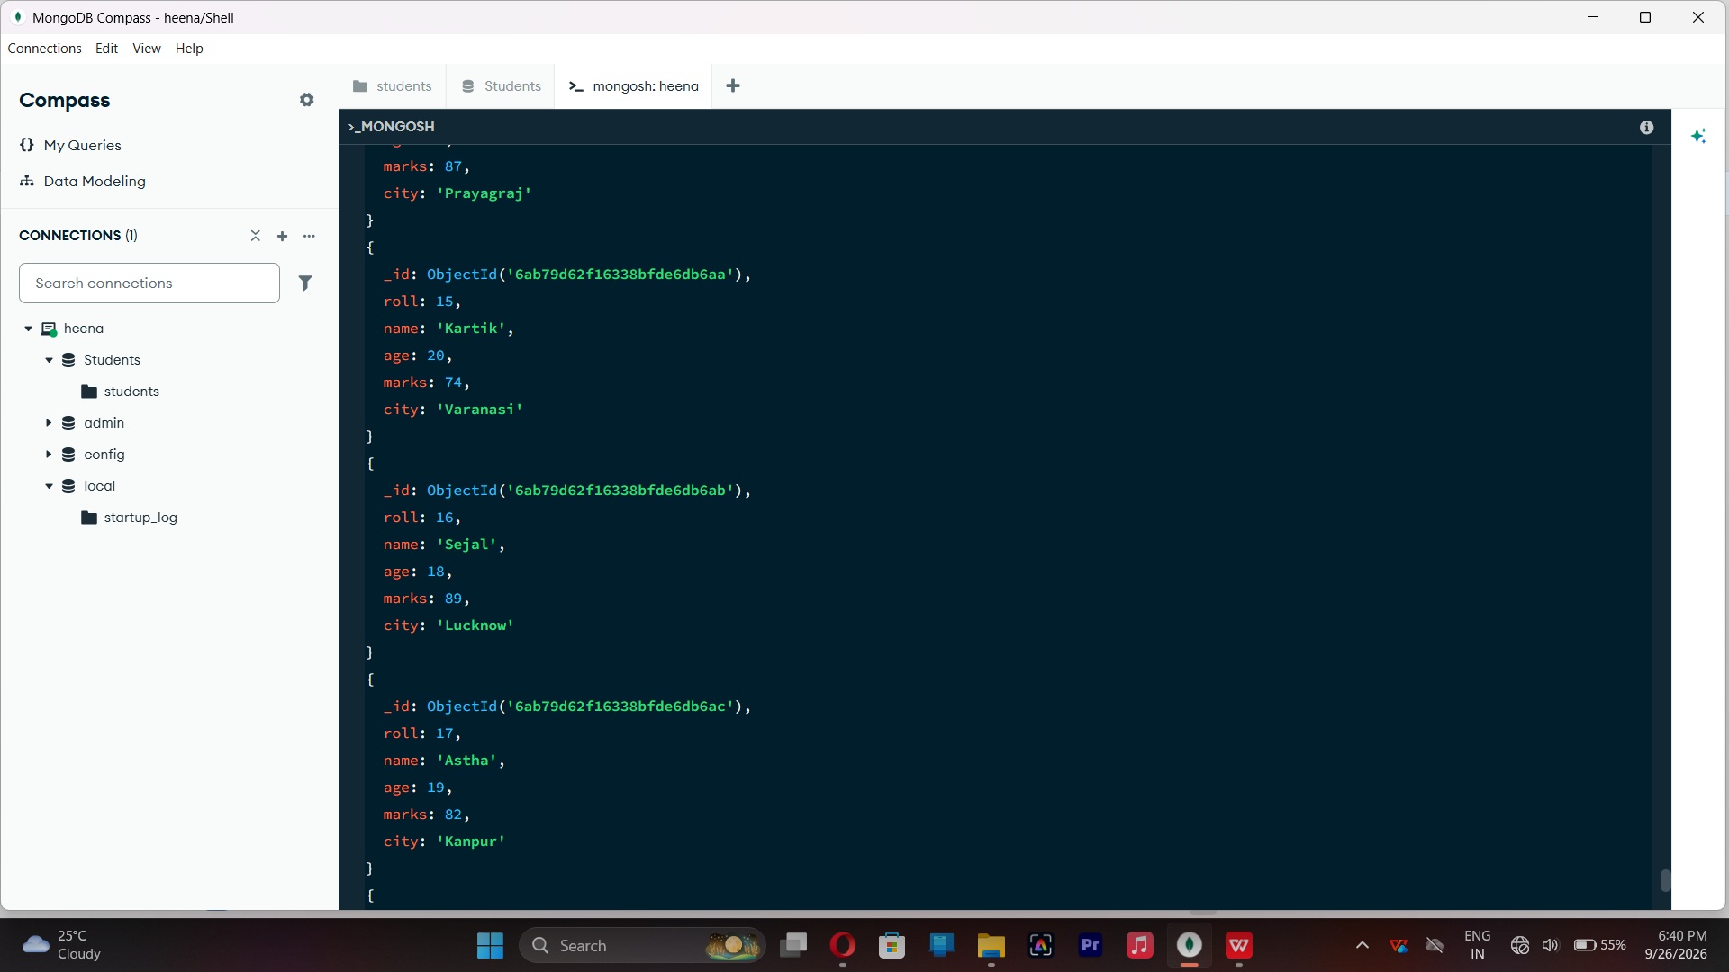

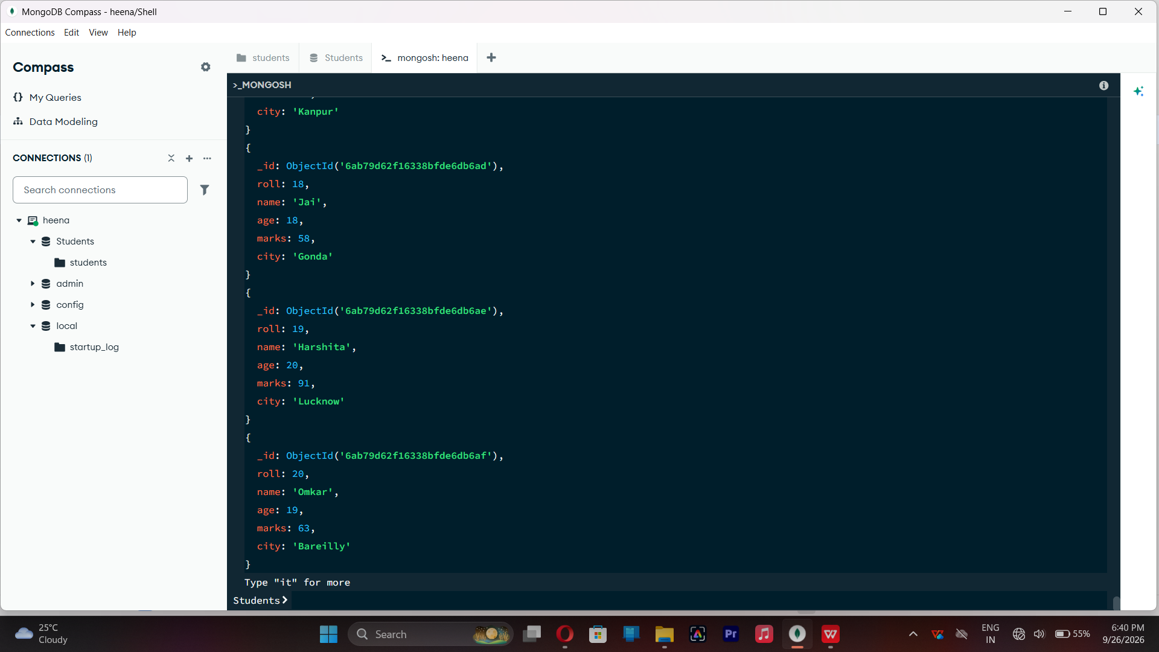

- EQUAL TO - $eq
db.students.find({marks:{$eq:88}})
Find students whose marks are exactly 88.
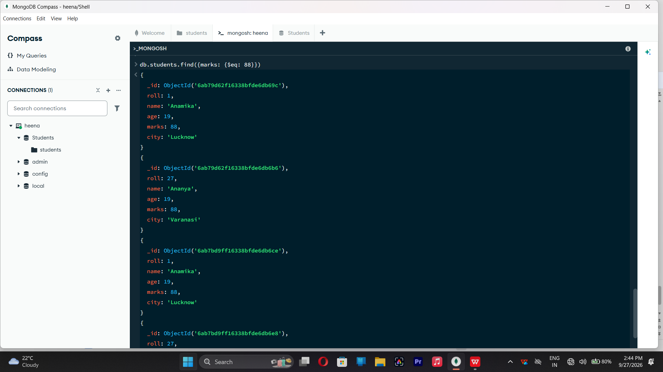
- GREATER THAN - $gt
db.students.find({marks:{$gt:85}})
Finds students whose marks are greater than 85.
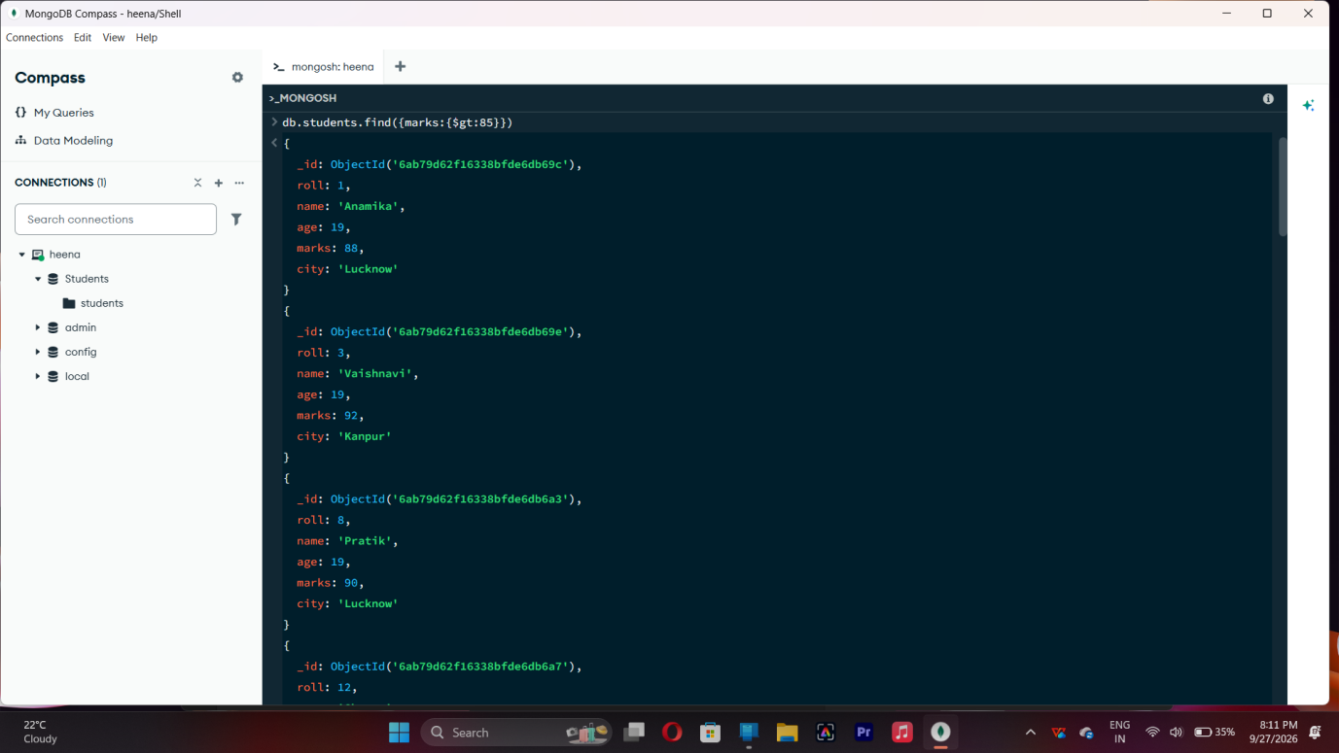

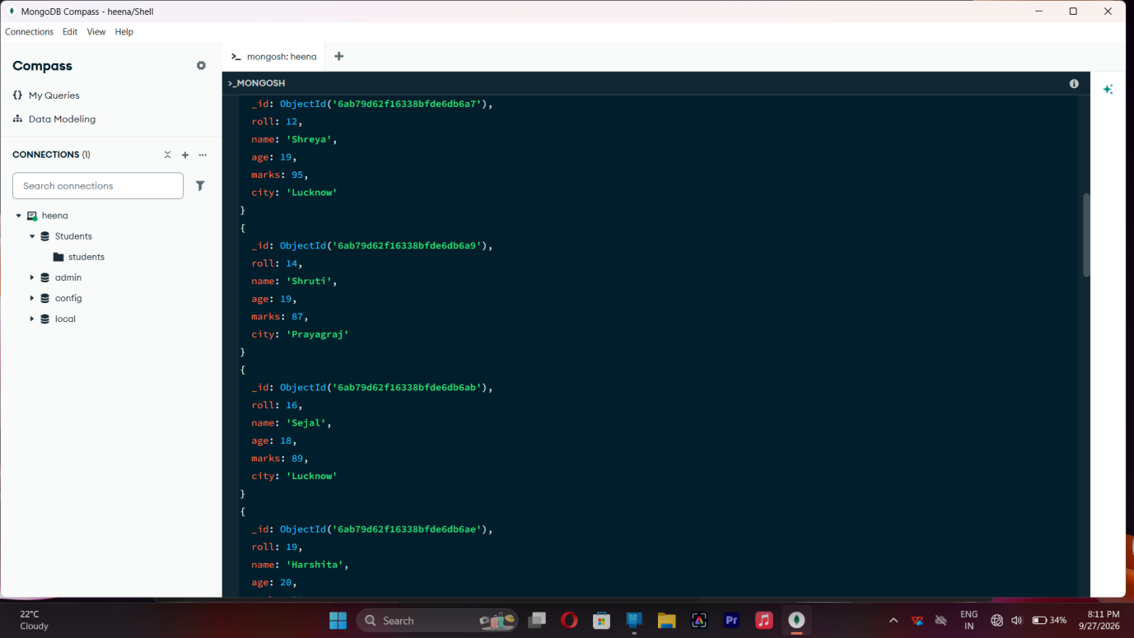
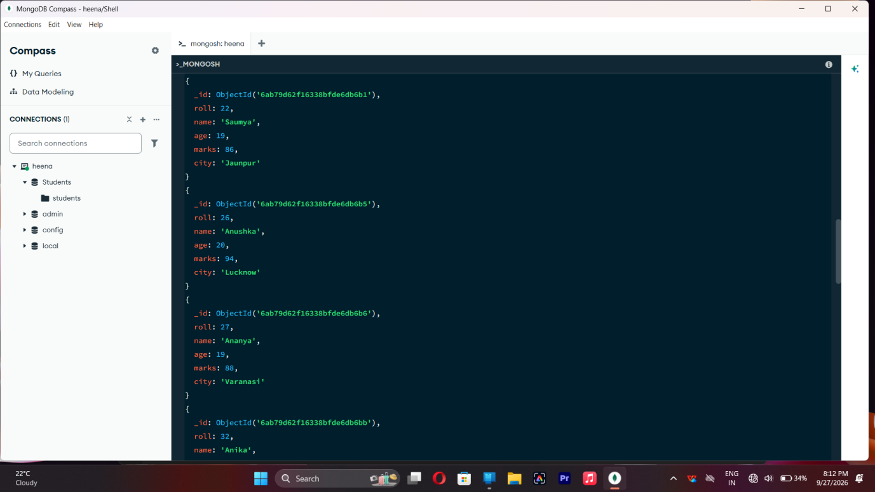

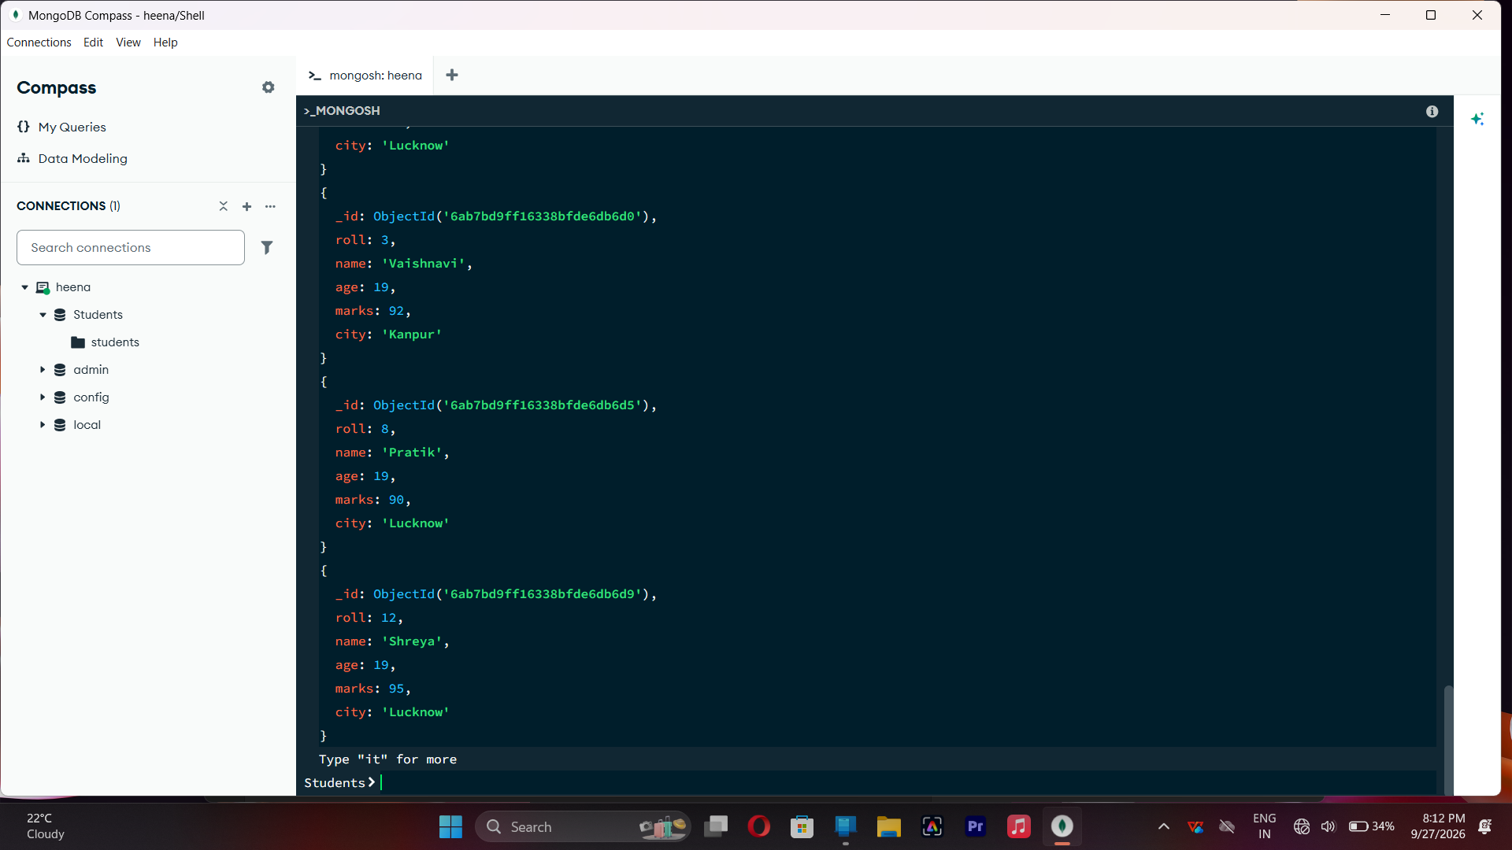

- LESS THAN - $lt
db.students.find({marks:{$lt:60}})
Finds students whose marks are less than 60.
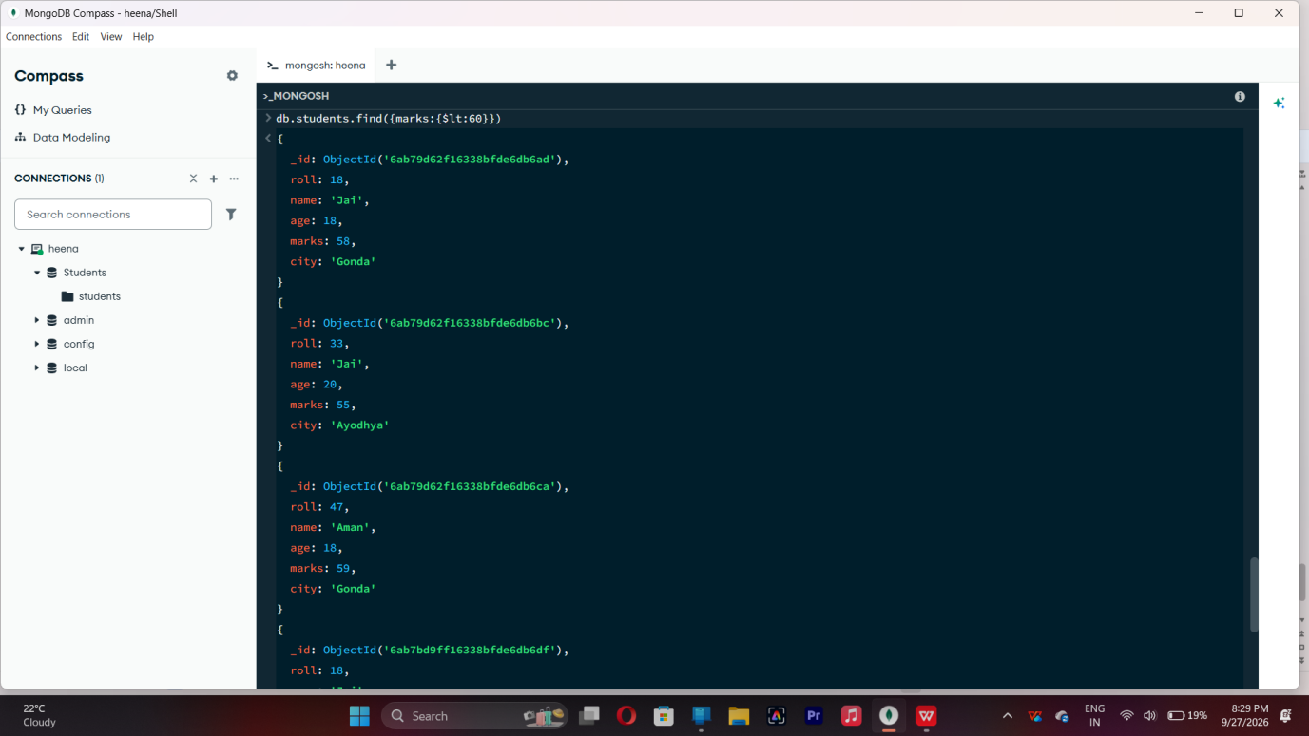

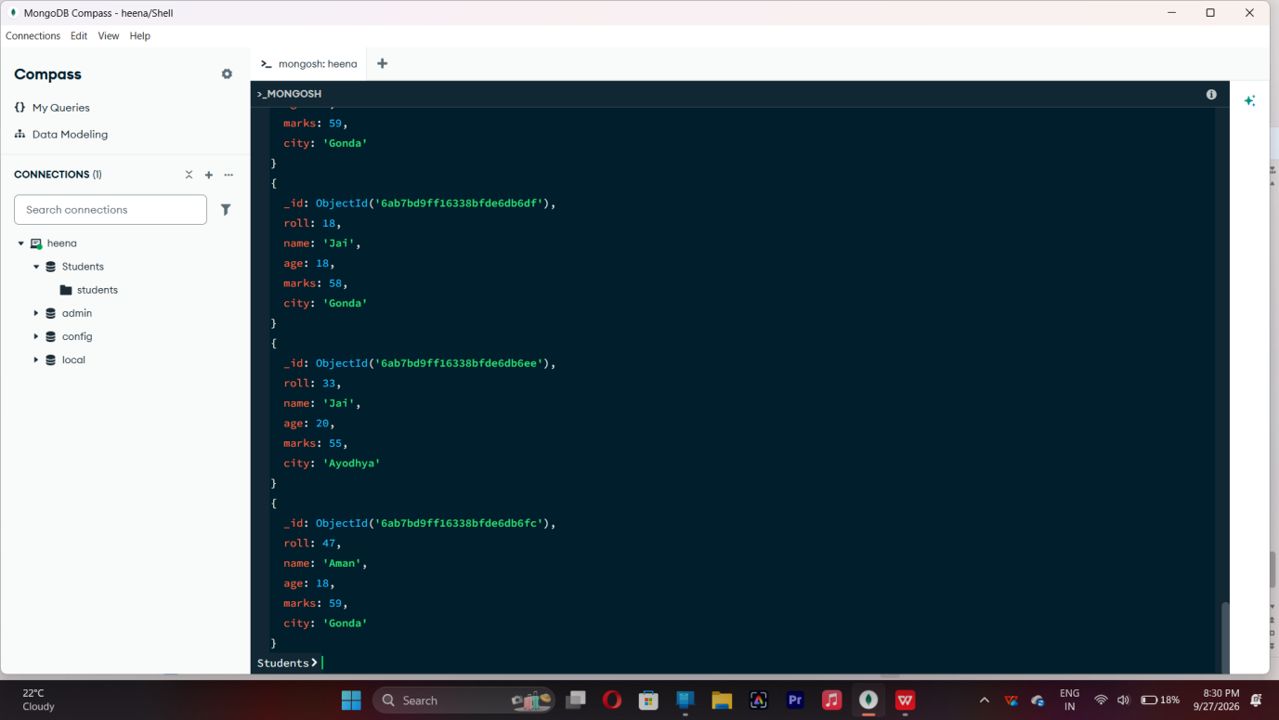

- GREATER THAN OR EQUAL TO - $gte
db.students.find({marks:{$gte:90}})
Finds students whose marks are 90 or above.

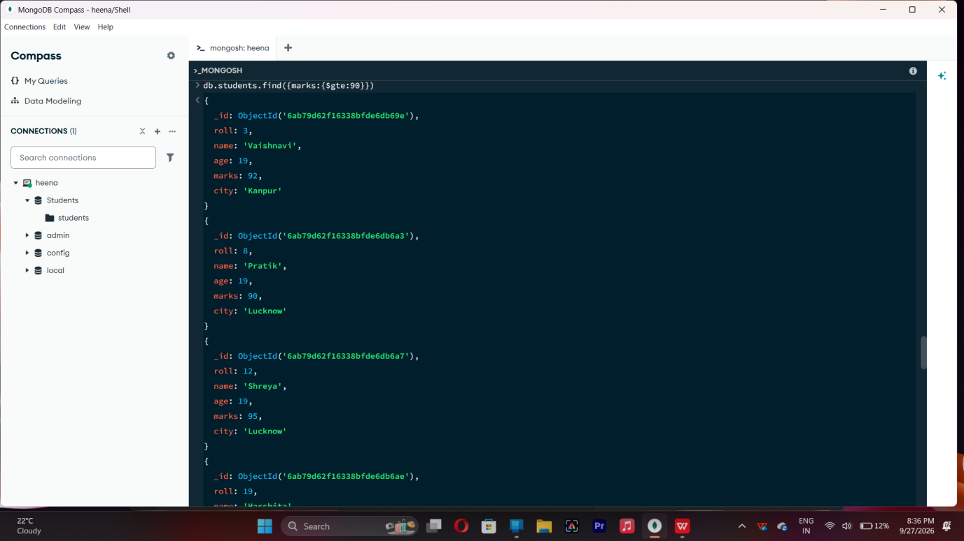

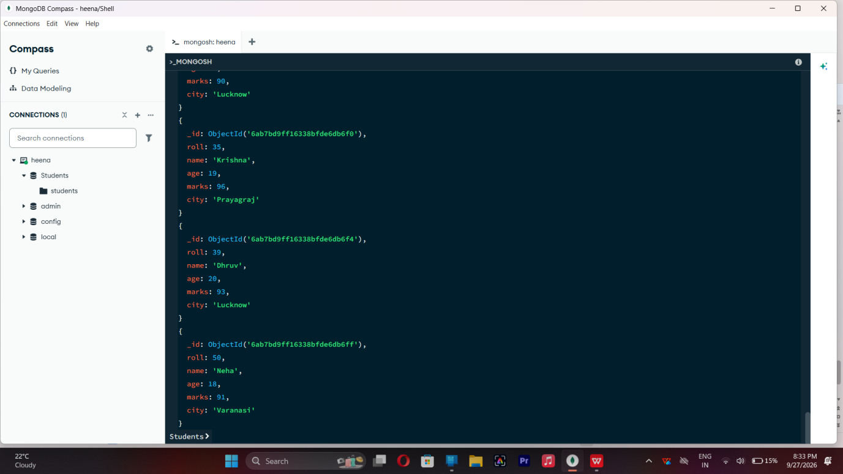

- LESS THAN OR EQUAL TO - $lte
db.students.find({marks:{$lte:70}})
Finds students whose marks are 70 or below.

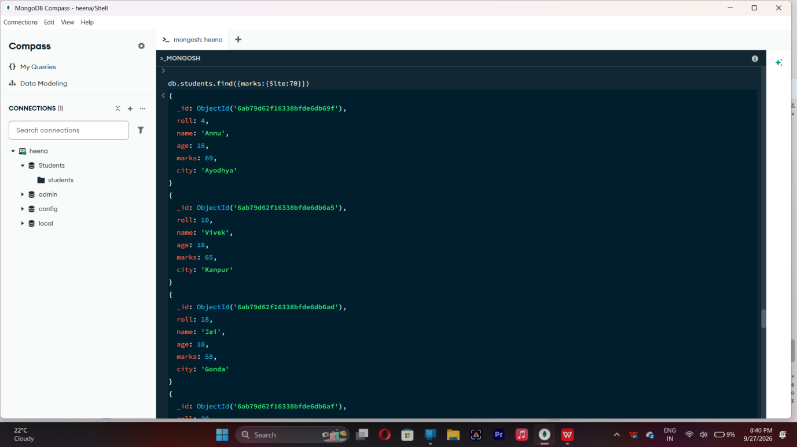

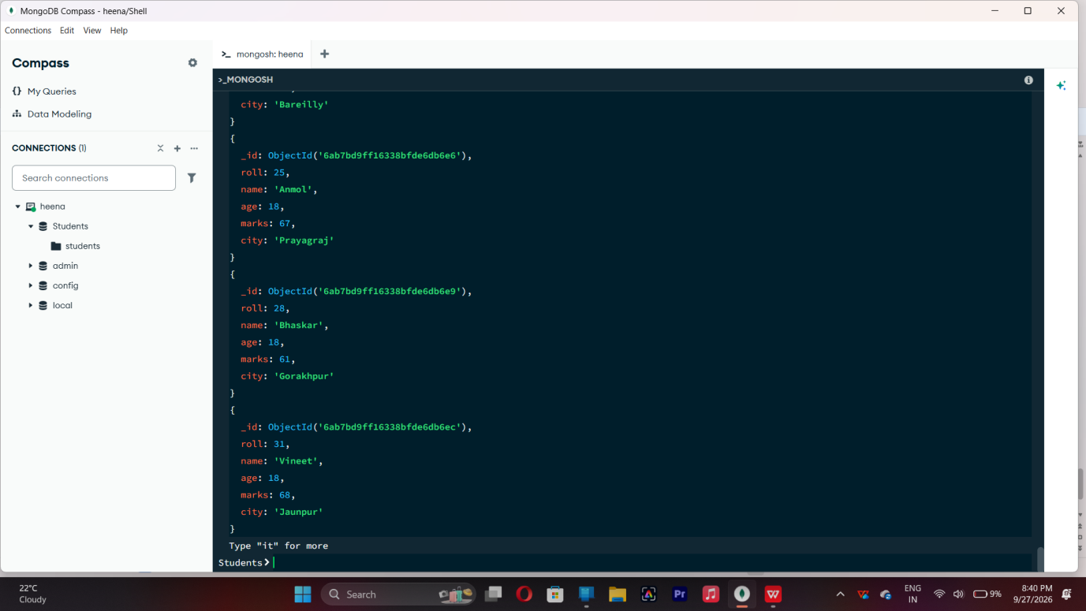

- UPDATE OPERATION

db.students.updateOne({roll:5},{$set:{marks:95}})

Updates the marks to 95 of the student with roll no 5.

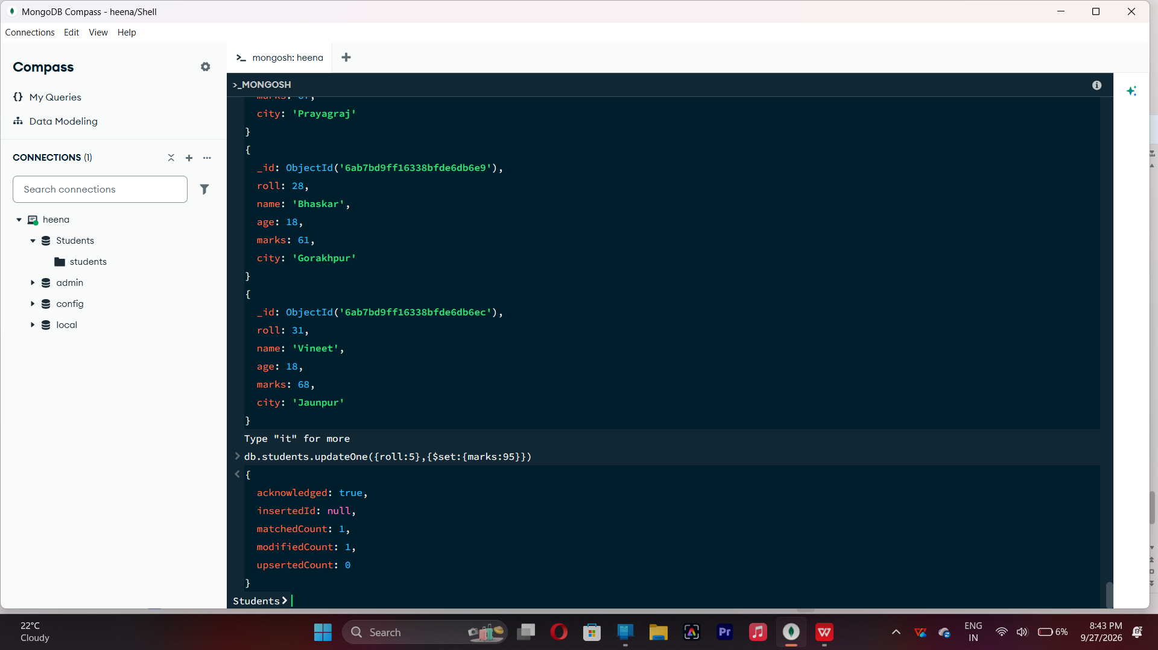

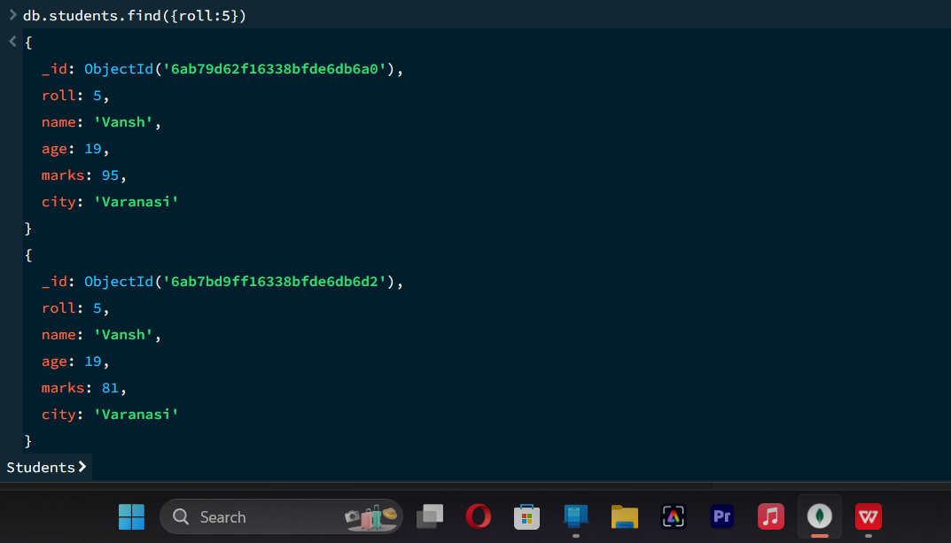

- DELETE OPERATION

db.students.deleteOne({roll:10})

Deletes one document matching roll no 10.

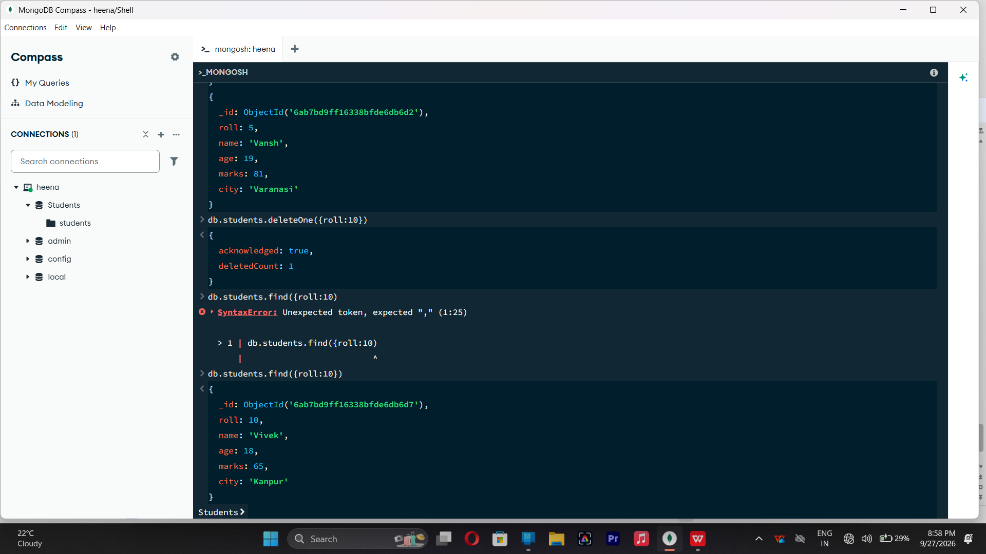

- DELETE MANY OPERATION

db.students.deleteMany({marks:{$lt:60}})

Deletes all students having marks below 60.

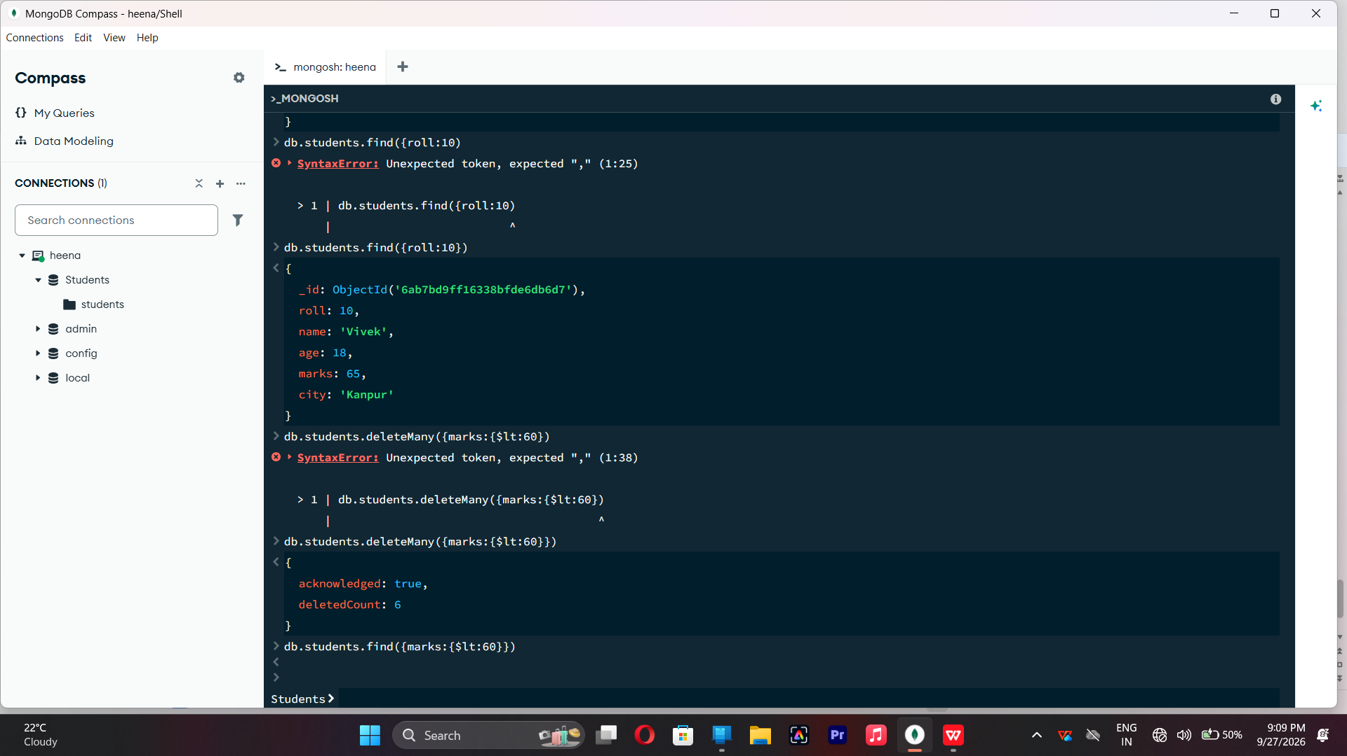

- AND OPERATION - $and

db.students.find({$and:[{marks:{$gt:80}},{age:19}]})

Finds students satisfying both conditions.

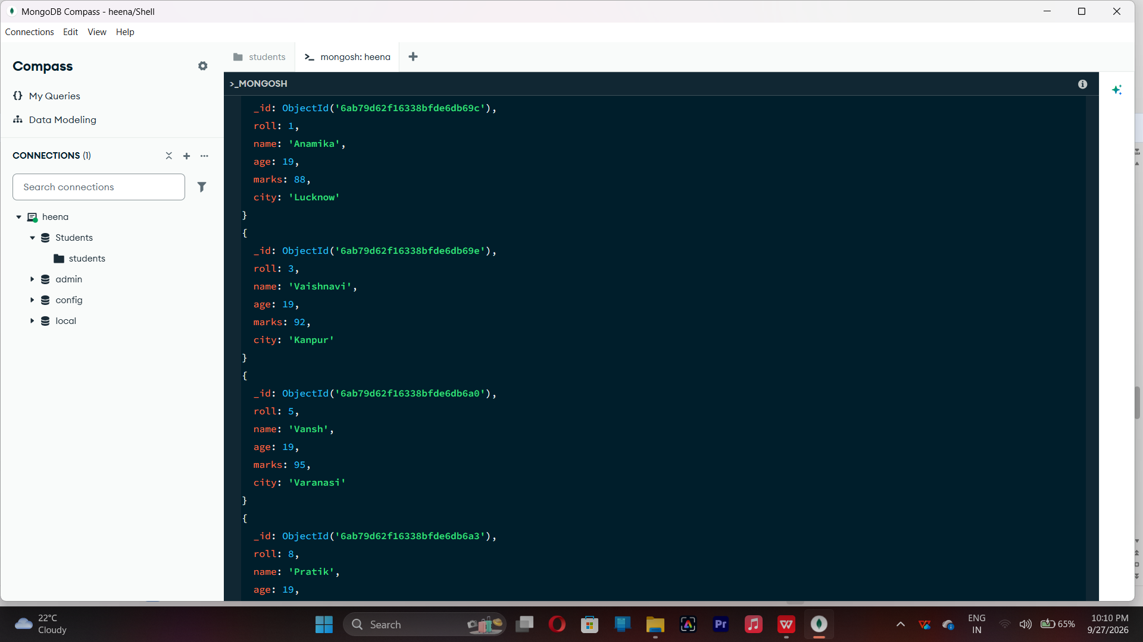

14. OR OPERATION — $or
db.students.find({$or:[{city:"Lucknow"},{city:"Kanpur"}]})

Finds students from Lucknow or Kanpur.

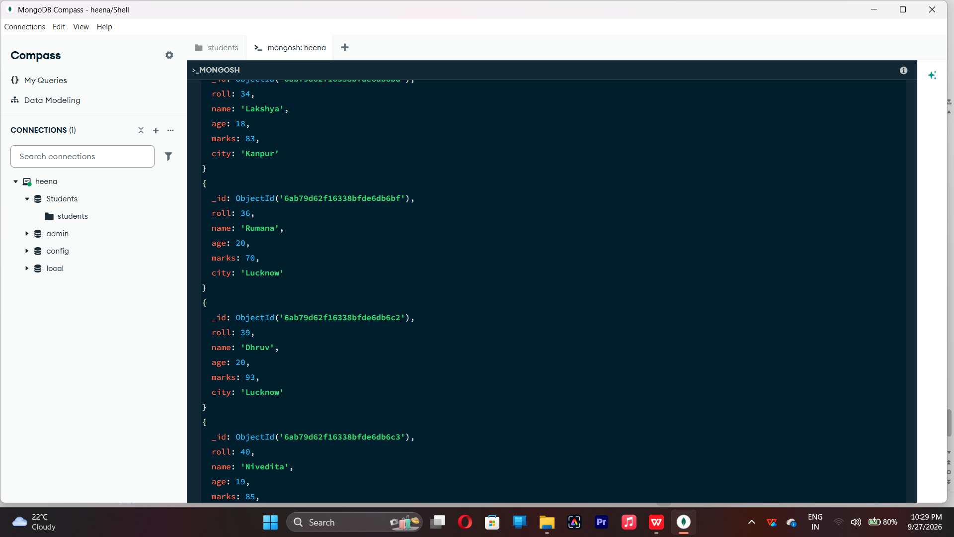

- SORT OPERATION
db.students.find().sort({marks : 1})

Sorts students by marks from lowest to highest. Use 1 for ascending order.

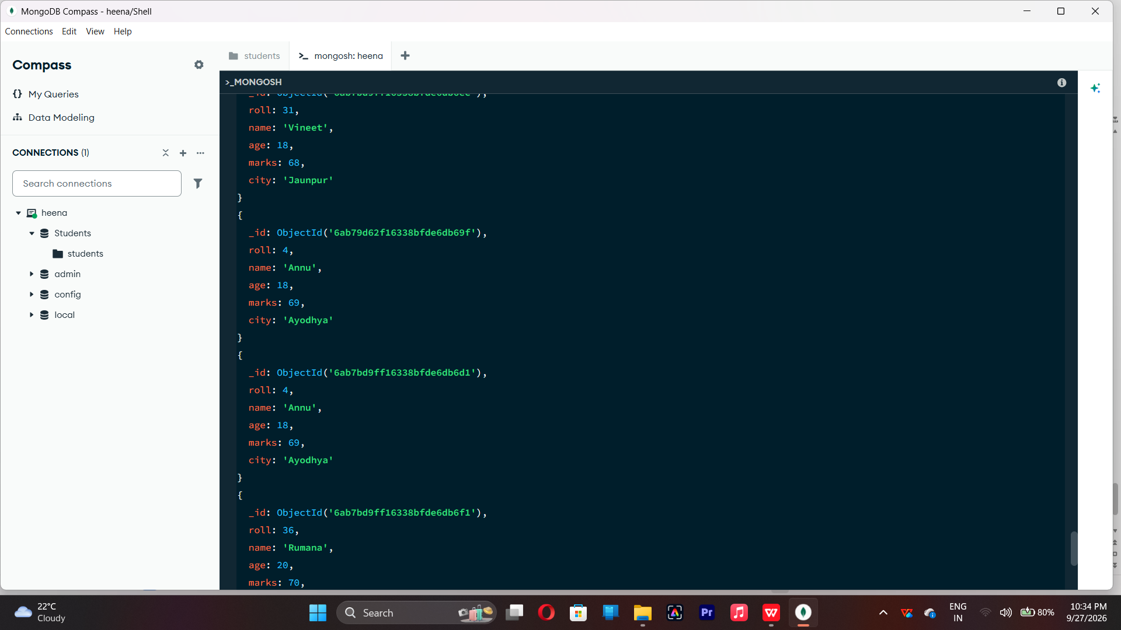

db.students.find().sort({marks: -1})
Sorts students by marks from highest to lowest. Use -1 for descending order.

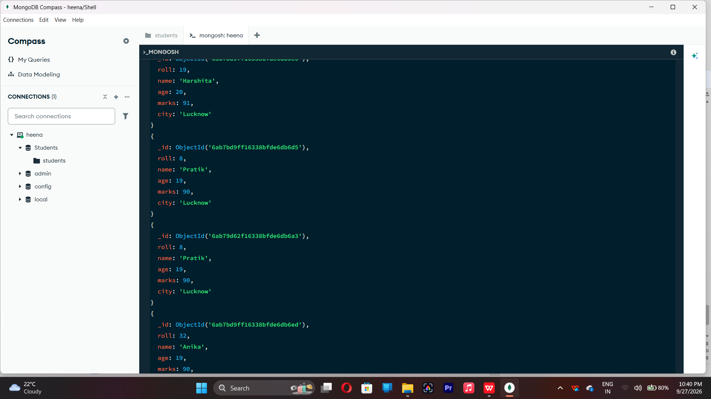

16. LIMIT OPERATION
db.students.find().limit(5)
Displays only the first five documents.

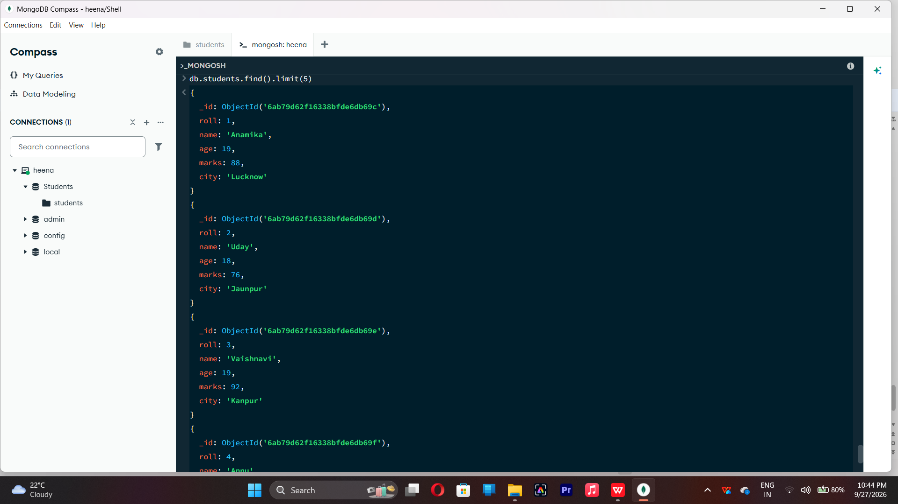
- SEARCH BY CITY

db.students.find({city:"Lucknow"})

Finds all students whose city is Lucknow.

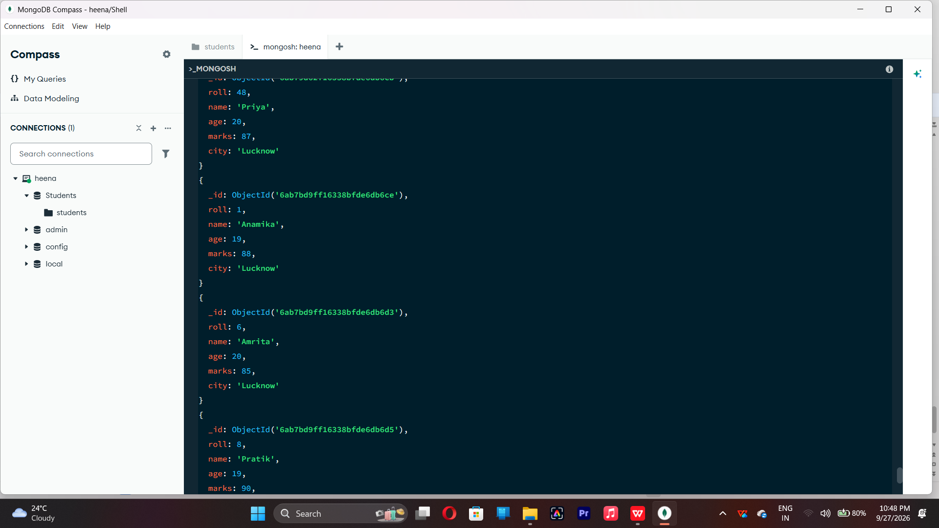
- COUNT DOCUMENTS

db.students.countDocuments()

Counts documents currently present in the collection (performing after the delete function).

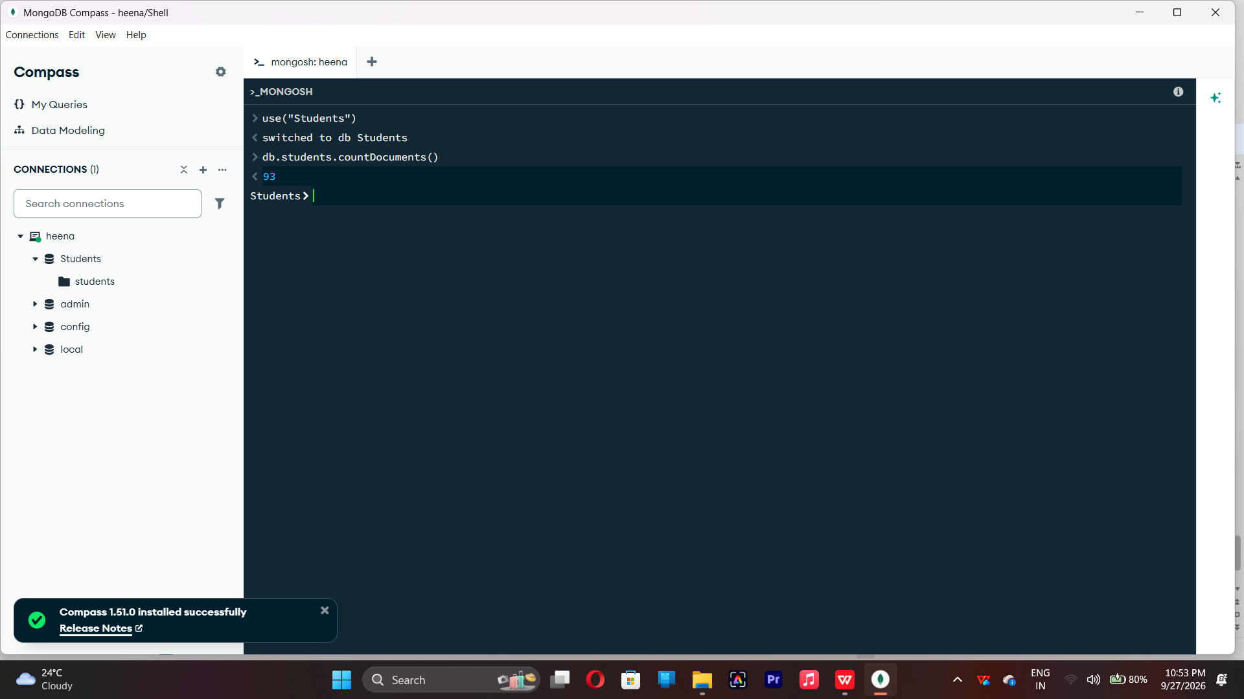

MONGODB OPERATORS USED:

Operators | Meaning | Example
$eq | Equal to | marks: {$eq:88}
$gt | Greater than | marks: {$gt:85}
$lt | Less than | marks: {$lt:60}
$gte | Greater than or equal to | marks: {$gte:90}
$lte | Less than or equal to | marks: {$lte:70}
$and | All conditions true | $and:[...]
$or | At least one condition true | $or:[...]

